**Ideation Phase**

**Brainstorm & Idea Prioritization Template**

|  |  |
| --- | --- |
| Date | 19 September 2022 |
| Team ID | NM2023TMID07609 |
| Project Name | Electronic Voting System |
| Maximum Marks | 4 Marks |

**Brainstorm & Idea Prioritization Template:**

**Brainstorming Sessions:** Describe the brainstorming sessions where project team members, stakeholders, or experts generated ideas and concepts for improving the electronic voting system. Highlight the diversity of ideas and perspectives considered.

**Idea Generation:** Explain the specific ideas and concepts that emerged during these brainstorming sessions. You can elaborate on the key features, innovations, or technologies that were proposed as potential solutions.

**Step-1: Brainstorm**

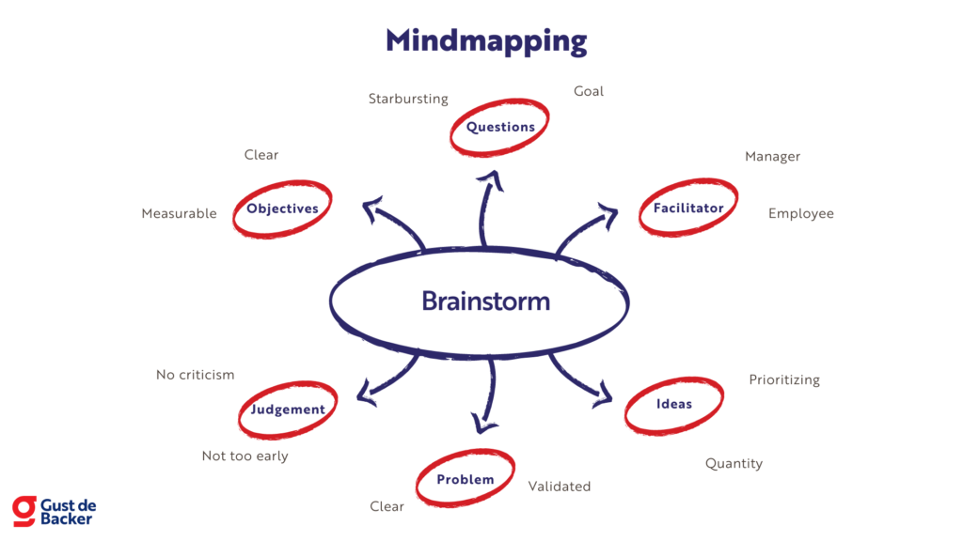

**Step-2: Idea Prioritization**

